In this project, I built a 3D scene using OpenGL to look like a reference image. The picture on the left is the reference image that I used as the basis for the scene, and the picture on the right is my finished 3D scene using OpenGL.

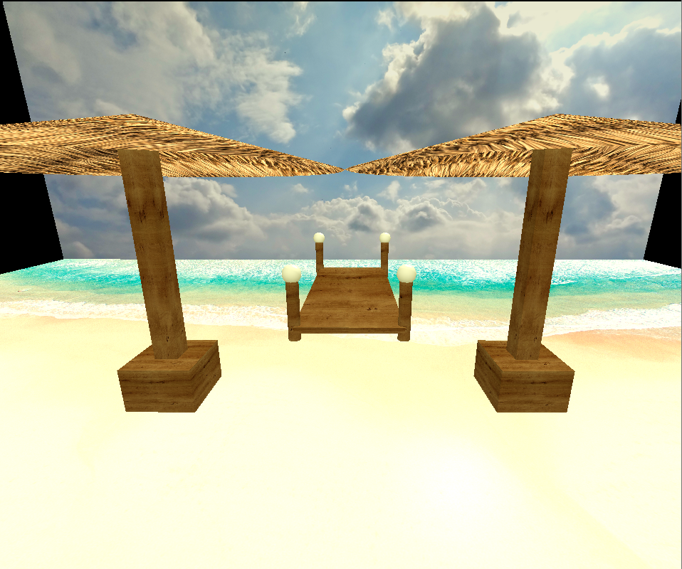

I chose this scene because I found it interesting, and it also had a nice variety of objects to create. In my scene I created the main objects but left some of the smaller, less important objects out such as the block of wood and stools on the dock. My scene consists of five main objects: the beach, the sky, two umbrellas, and a dock. Both the umbrellas and the dock are complex objects consisting of multiple shapes. The umbrellas consist of a wooden box base with a wooden square pole and thatch cone roof on top. The dock consists of a wooden plank with four pillars. The pillars are wooden cylinders with a shiny sphere cap on top. This is slightly different from the reference image, but I chose to use a sphere for the pole top since I already had used a cone for the umbrellas. For the lights, I used a white light in front of the scene to make sure everything had good ambient light. I also added a bright yellow light in the top back right to mimic the sun shining down on the scene. This has more specural light and will illumante shiny objects like the dock orbs. All together, I believe these combinations of objects create a compelling 3D scene modelled after the reference image.

To navigate this 3D scene, there are keyboard and mouse movement controls. The WASD keys can be used to move the camera forward, backward, left, and right. The QE keys can be used to move the camera up and down. The mouse can be moved around to change the direction of the camera. Additionally, the scroll wheel can be zoomed to change the movement speed. Finally, pressing the O and P keys can be used to switch to orthographic and perspective views.

To make my code more modular and organized, I grouped operations into several functions. I create a function to build the umbrella. This was useful because the umbrella was duplicated and I could call this twice to make both umbrellas. I then created a function for the dock. This was beneficial because the dock needed to make several complex objects together. Finally, I created a function for the dock pole. This was necessary because there are four dock poles in the scene and this reduces duplication and makes placement of the x,y, and z much easier.